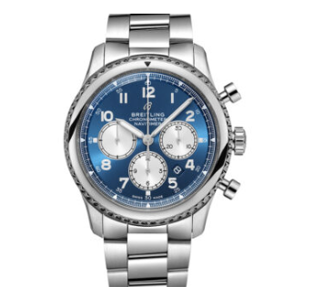

**Product Name:** Breitling chronometer B01 42

**Description:** The Breitling chronometer B01 42 is a luxury Swiss timepiece with a refined design and advanced functionality. It features a robust stainless steel case and bracelet, complemented by a striking blue dial. The watch includes a chronograph function with three sub-dials, offering precise timekeeping for professional and casual wear. The textured bezel adds to its bold aesthetic, while the date window placed between the 4 and 5 o'clock markers enhances practicality. Equipped with Breitling's signature automatic movement, this watch blends performance with elegance, making it a perfect choice for collectors and enthusiasts.

**Specifications:**

* **Brand:** Breitling
* **Model:** Chronomat B01 42
* **Case Material:** Stainless Steel
* **Band Material:** Stainless Steel
* **Dial Color:** Blue
* **Bezel:** Textured, Stainless Steel
* **Sub-dials:** Three (Chronograph functions)
* **Date Window:** Positioned between 4 and 5 o'clock markers
* **Crown:** Stainless Steel, screw-down
* **Push Buttons:** Two (for chronograph operations)
* **Movement:** Breitling Manufacture Caliber B01 (Automatic)
* **Power Reserve:** Approximately 70 hours
* **Crystal:** Sapphire, anti-reflective coating
* **Water Resistance:** Up to 200 meters

**Price:**

**$10,000 USD**.